SPORTSCIENCE | sportsci.org
Review: Biochemistry
Exercise-Induced Metabolic Acidosis:
Where do the Protons come from?
Robert A Robergs
Exercise Science Program, University of New Mexico, Albuquerque, NM 87059, USA. Email: rrobergs@unm.edu
Sportscience 5(2), sportsci.org/jour/0102/rar.htm, 2001 (7843 words)
Reviewed by Lawrence Spriet, Department of Human Biology and Nutritional Science, University of Guelph, Ontario, Canada
The widespread belief that intense exercise causes the production of “lactic acid” that contributes to acidosis is erroneous. In the breakdown of a glucose molecule to 2 pyruvate molecules, three reactions release a total of four protons, and one reaction consumes two protons. The conversion of 2 pyruvate to 2 lactate by lactate dehydrogenase (LDH) also consumes two protons. Thus lactate production retards rather than contributes to acidosis. Proton release also occurs during ATP hydrolysis. In the transition to a higher exercise intensity, the rate of ATP hydrolysis is not matched by the transport of protons, inorganic phosphate and ADP into the mitochondria. Consequently, there is an increasing dependence on ATP supplied by glycolysis. Under these conditions, there is a greater rate of cytosolic proton release from glycolysis and ATP hydrolysis, the cell buffering capacity is eventually exceeded, and acidosis develops. Lactate production increases due to the favorable bioenergetics for the LDH reaction. Lactate production is therefore a consequence rather than a cause of cellular conditions that cause acidosis. Researchers, clinicians, and sports coaches need to recognize the true causes of acidosis so that more valid approaches can be developed to diminish the detrimental effects of acidosis on their subject/patient/client populations.
KEYWORDS: lactate, lactic acid, glycolysis, ATP, hydrolysis.

Introduction 2
The Biochemistry of Metabolic Acidosis 2
Fundamentals of Acid-Base Physiology 3
The Source of Protons During Catabolism In Skeletal Muscle 5
Phosphagen Energy System: Creatine Kinase Reaction 5
Phosphagen Energy System: Adenylate Kinase Reaction 6
Phosphagen Energy System: AMP Deaminase Reaction 6
Phosphagen Energy System: ATP Hydrolysis 7
Phosphagen Energy System: Summary 8
Glycolysis 9
The Lactate Dehydrogenase Reaction 13
The Balance of Proton Production and Consumption in Muscle Contraction 13
Summary of Cytosolic Proton Exchange 15
Application of Biochemistry of Acidosis to Exercise Physiology 17
Why is Lactic Acid Still Thought to Cause Acidosis? 18
Editor’s Comment 18
Author’s Response 18
References 19

Introduction
The scientific method involves stringent criteria for the evaluation of knowledge, but the method is not perfect. Research findings and their interpretations can be raised prematurely to the status of a fact. Some of these “facts” can even become a pivotal component of a knowledge base, termed a construct. Consequently, continual re-evaluation of the content of any academic discipline or profession is essential to ensure that knowledge and practice is based on fact.
In recent years I have come to question a construct that has been accepted by a wide range of academic, research and professional entities: that the increasing free proton concentration within contracting skeletal muscle is caused by the increased production of “lactic acid”. One only has to read any of the textbooks in exercise physiology or pure biochemistry to be informed that when “pyruvic acid” is converted to “lactic acid”, the pK of “lactic acid” results in an immediate, near complete dissociation of the proton from the carboxylic acid functional group. This interpretation results in the logical belief that the net result in vivo is the production of lactate ions and the release of a proton. A generic chemical equation used to support this explanation is as follows:
Pyruvic acid + NADH + H⁺ ↔ lactic acid + NAD⁺ → lactate⁻Na⁺ + NAD⁺ + H⁺
This equation is typically extended to illustrate the bicarbonate buffering of the proton from lactate, resulting in the non-metabolic production of carbon dioxide (Brooks et al., 2000).
Lactate-H + Na⁺ → Na⁺-Lactate⁻ + H⁺
H⁺ + HCO₃⁻ ↔ H₂CO₃ ↔ H₂O + CO₂
Physiology is then extended to provide a cause-effect association between lactate production, the development of acidosis, the added free H⁺ and CO₂ stimulation of ventilation, and the temporal alignment of the lactate and ventilatory thresholds.
The above physiological and biochemical interpretations of a lactate-dependent acidosis during exercise are so engrained that hundreds of papers published every year directly or indirectly refer to it. The error of the “lactic acidosis” construct in biochemistry and physiology is that it is not based on fact. Acidosis arises elsewhere than the lactate dehydrogenase (LDH) reaction.
The Biochemistry of Metabolic Acidosis
Before I commence my biochemical explanation of the development of acidosis during exercise, I must stress that the concepts and explanations are not new. Credit is due to Gevers (1977) for his initial publication and response (Gevers, 1979) to criticisms (Wilkie, 1979) of his alternate views and explanations of metabolic acidosis in cardiac muscle. Subsequent reviews and commentaries of the biochemistry of metabolic acidosis have substantiated the views of Gevers. For example, Vaghy (1979) presented evidence for the incorporation of cytosolic protons (hydrogen ions free in the cytoplasm) into mitochondrial respiration within cardiac muscle, and he theorized that any deficit in mitochondrial respiration would contribute to acidosis. Dennis co-authored a manuscript with Gevers 14 years later (Dennis et al., 1991) that explained the importance of ATP hydrolysis to cytosolic proton production and accumulation. Similarly, additional researchers have questioned the concept of a “lactic acidosis” and proposed a combination of glycolysis and ATP hydrolysis to be the biochemical causes of proton release and accumulation (Busa and Nuccitelli, 1984; Hochachka and Mommsen, 1983; Noakes, 1977; Zilva, 1978).
It has been almost 25 years since the original publication of Gevers (1977), and there is no evidence in textbooks of the recognition that lactate production does not cause acidosis. The “lactic acid” cause of acidosis, termed a “lactic acidosis”, is still being taught in physiology and biochemistry courses throughout the world. Researchers in prestigious international journals are still using “lactic acid” and “lactic acidosis” terminology (e.g., Hagberg, 1985; Juel, 1996, 1998; Katz and Sahlin, 1988; Stringer et al., 1994). Clearly, a topic of this importance to basic and applied physiology, as well as to clinical medicine, must be based on fact and not an unproven theory. A re-evaluation of the biochemistry of exercise-induced metabolic acidosis is long overdue.
Fundamentals of Acid-Base Physiology
Prior to explaining current and proposed interpretations of the biochemistry of metabolic acidosis, I will clarify the difference between an acid and acid salt. An acid is a molecule that at neutral pH will release a proton into solution. Depending on the size of the molecule, the proton comes from a specific type of chemical structure on the molecule, typically called a functional group. Larger acid molecules can have more than one acid functional group, such as many of the amino acids. Some acid molecules are too small to contain acid functional groups, but they are still acids (e.g., hydrochloric acid, HCl; perchloric acid, HClO₄; phosphoric acid, H₃PO₄). Figure 1 presents two examples of acid functional groups within cellular metabolism: the carboxyl and phosphoryl groups. The carboxyl group is theorized, within the “lactic acidosis” construct, to play the greater role in cellular metabolic acidosis.

Figure 1: A structural illustration of the two main acid functional groups within cellular metabolism. Structures are drawn in their uncharged (unionized) form. The proton released in solution is shown in pink (H).
Carboxyl | Phosphoryl

The strength of an acid relates to the propensity for the molecule to release a proton in solution, even when the solution is already acidic (pH below 7). Thus, strong acids will release a proton until a relatively low pH is reached, at which time there is a dynamic equilibrium between the protons that leave and re-attach to the acid functional group of the molecule. Consequently, to better understand the proton releasing potential of an acid, it is necessary to know at what pH the release of the proton reaches this dynamic equilibrium. This pH is denoted as the negative log₁₀ of the ionization constant, abbreviated as pK'.
At equilibrium; HA ↔ H⁺ + A⁻, where
K = products/substrates = ([H⁺] [A⁻]) / [HA]
pK' = -log K = log(1/K)
The pK, which represents the pH at which half of the acid molecules are deprotonated (ionized), can be determined in vitro by titration. As you should be able to predict, strong acids or acid functional groups have a pK' much lower than 7, and weak acids have pK' values closer to 7.0. The pK' values for a selection of acids and acid functional groups are listed in Table 1.

Table 1: The pK’ values for specific acids or their functional groups (at 25°C).
 | Functional Group | pK'
Physiologic Acid Molecules
Acetic acid (CH₃COOH) | -COOH (carboxyl) | 4.78
Carbonic acid (H₂CO₃) | NA | 3.77
Glutamic acid ((COOH)CH(NH₃)CH₂CH₂COOH) | -αCOOH (carboxyl) | 2.2
Glutamic acid ((COOH)CH(NH₃)CH₂CH₂COOH) | -side chain COOH (carboxyl) | 4.3
Glutamic acid ((COOH)CH(NH₃)CH₂CH₂COOH) | -αNH₃⁺ (amino) | 9.7
Histidine ((COOH)CH(NH₃)CH₂C(NHCHN)CH) | -αCOOH (carboxyl) | 1.8
Histidine ((COOH)CH(NH₃)CH₂C(NHCHN)CH) | -side chain | 6.0
Histidine ((COOH)CH(NH₃)CH₂C(NHCHN)CH) | -αNH₃⁺ (amino) | 9.2
Phosphagen System
Ammonia (NH₄⁺) | NA | 9.25
Inorganic Phosphate (H₃PO₄) | NA | 2.15  6.82  12.4
Glycolysis
3-phosphoglyceric acid (CH₂(OH)CHO(PO₃)COOH) | -COOH (carboxyl) | 3.42
2-phosphoglyceric acid (CH₂O(PO₃)CH(OH)COOH) | -COOH (carboxyl) | 3.42
Phosphoenolpyruvic acid (CH₂CO(PO₃)COOH) | -COOH (carboxyl) | 3.50
Pyruvic acid (CH₃COCOOH) | -COOH (carboxyl) | 2.50
LDH Reaction
Lactic acid (CH₃CH(OH)COOH) | -COOH (carboxyl) | 3.86
Adapted from Stryer (1988), Lehninger et al. (1993), Nelson et al. (2000).

After an acid molecule loses a proton, it attains a negative ionic charge. To maintain charge neutrality, a cation ionically binds to the negative charge, resulting in an acid salt. Due to the intracellular and extracellular abundance of sodium (Na⁺) and potassium (K⁺), both being singly charged cations, deprotonated acids are predominantly sodium or potassium salts. Note that in Table 1 the pK' of lactic acid is reported to be 3.86. Hence, the main form of “lactic acid” in physiological systems is sodium lactate (La⁻Na⁺).
Finally, it should be emphasized that acid production is not the only source of proton release within a cell. Protons can also be released from chemical reactions, and I will show that this source of protons is the main cause of acidosis in contracting skeletal muscle. In addition, Stewart (1983) has clearly indicated that the movement of charged ions across the muscle cell membrane can influence cell acid-base balance, and this approach to understanding acid-base balance has been termed the “strong ion difference”. Additional research on the “strong ion difference” has shown that it is associated with contributions to proton accumulation within contracting muscle cells, presumably due to the efflux of potassium from muscle during intense exercise (Lindinger and Heigenhauser, 1991). In this manuscript I focus on proton release and consumption, and I will not consider further the influence of the strong ion difference on pre-existing proton kinetics.
The Source of Protons During Catabolism In Skeletal Muscle
In the sections that follow, I will explain the cytosolic reactions of energy catabolism. I will commence with the reactions of the phosphate energy system, and then the reactions of glycolysis, finishing with the LDH reaction. For all reactions that involve either a proton consumption or release, I provide structures to illustrate the exchange of atoms, electrons and protons. These atomically balanced equations are not provided in textbooks of biochemistry or exercise physiology, which may explain why the biochemistry of acidosis is so poorly understood!
Phosphagen Energy System: Creatine Kinase Reaction
The creatine kinase (CK) reaction is of vital importance to skeletal muscle contraction. This reaction provides the most immediate means to replenish ATP in the cytosol. Traditionally, the reaction has been interpreted to be applicable mainly to the metabolic needs of intense exercise, the transition to increased exercise intensities, or during conditions of hypoxia. However, creatine phosphate (CrP) probably assists in the transfer of terminal phosphates throughout the cytosol, as well as from the mitochondria to the cytosol. This function is summarized as the linked reactions of the “creatine phosphate shuttle” (Karlsson, 1971; Kent-Braun et al., 1993). The chemical equation of the CK reaction follows:
Creatine Phosphate + ADP + H⁺ ↔ Creatine + ATP
In vivo the CK reaction is actually a coupled reaction involving breakdown of CrP and the phosphorylation of ADP. It is incorrect to refer to this in vivo reaction as hydrolysis of CrP. Hydrolysis of CrP can occur in vitro, where water is required to provide the atoms and electrons needed to produce creatine, inorganic phosphate (Pi), and a proton.
The CK reaction is referred to as an equilibrium reaction, as in vivo the free energy change (ΔG) approximates zero. Thus, when the product of the molecules on the left side of the equation increase relative to the right side of the equation, such as during exercise of increasing intensity, the reaction direction becomes exergonic in the direction of ATP regeneration. The reaction reverses direction during recovery from exercise.
The structural components of the creatine kinase reaction are detailed in Figure 2. The reaction involves the transfer of a phosphate from CrP to ADP to form ATP. During exercise, increased rates of the CK reaction actually cause a slight alkalinization of skeletal muscle due to the consumption of a proton in the reaction (Karlsson, 1971, Dennis, 1991; Gevers, 1977). In order to reform the amine terminal of creatine, a proton from solution is consumed in the reaction, thus explaining the alkalinization. The carboxyl group of creatine (Cr) is already ionized at physiological pH (Table 1) and does not contribute to the alkalinization.

Figure 2: A structural illustration of the creatine kinase reaction.
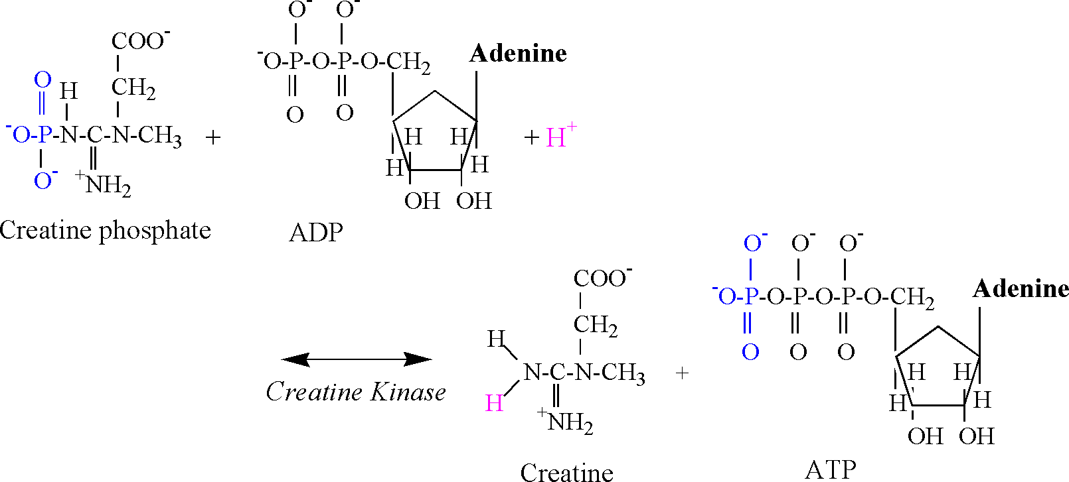

The biochemistry of the CK reaction indicates that 1 proton is consumed for every phosphate transfer from CrP to ADP, forming ATP. Thus, the CK reaction functions as a small “sink” for protons, with an immediate capacity during exercise equal to the number of CrP molecules that transfer their phosphate to ADP.
Phosphagen Energy System: Adenylate Kinase Reaction
For increasing exercise intensities that extend into non-steady state conditions, not only does the activity of the CK reaction increase, but the second reaction of the phosphagen system also increases; the adenylate kinase (AK) (or myokinase) reaction. The chemical equation of the AK reaction follows:
ADP + ADP ↔ ATP + AMP
The production of AMP is important. AMP increases the activity of phosphorylase, thereby increasing glycogenolysis, as well as stimulating increased activity of phosphofructokinase. The result of this stimulation is an increased rate of glucose 6-phosphate formation to fuel glycolysis, and an increased rate of glycolytic flux. As will be discussed, this increased flux through glycolysis increases proton release and eventually decreases cellular pH.
Phosphagen Energy System: AMP Deaminase Reaction
The activity of the adenlyate kinase reaction is best detected by increases in muscle adenosine monophosphate (AMP) and inosine monophosphate (IMP). The production of IMP results from an increased activity of the AMP deaminase reaction, which is activated by acidosis and produces IMP and ammonia (NH₄);
AMP + H⁺ ↔ IMP + NH₄
The reaction consumes a proton due to the initial formation of NH₃ (Figure 3). The high pK of ammonia then results in addition of a proton. Adding the increased concentration of ADP to the AMP and IMP produced in skeletal muscle (ΔADP + AMP + IMP) accounts for the small decreases in ATP experienced during intense exercise to fatigue.

Figure 3: A structural illustration of the AMP deaminase reaction.
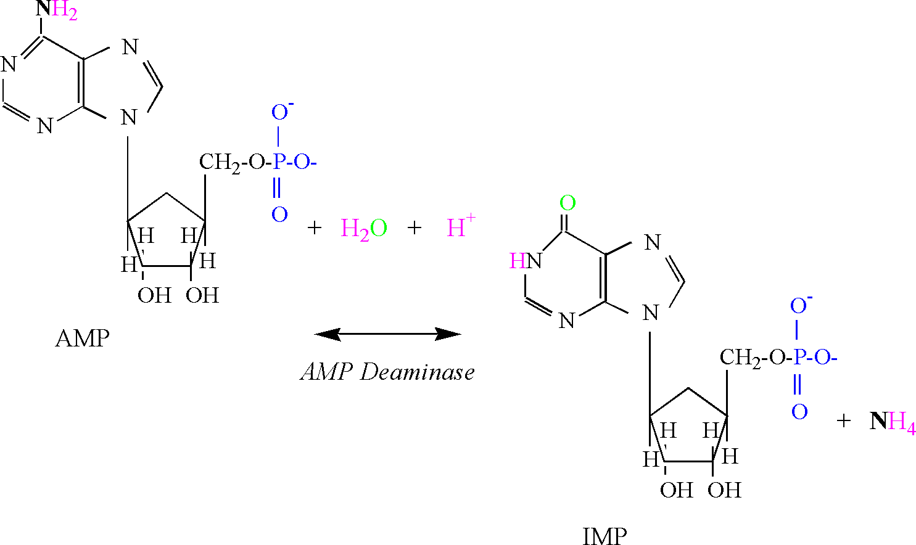
It is important to recognize that the AK and AMP deaminase reactions reflect an inability for mitochondrial respiration to totally replenish ATP within the cytosol of the cell. Research indicates that these cellular conditions are associated with the greatest ATP regeneration from the phosphagen system and glycolysis, and coincide with a rapid increase in lactate and proton accumulation (decreased pH) (Karlsson, 1971; Sahlin, 1978; Sahlin et al., 1987; Katz and Sahlin, 1988).
Phosphagen Energy System: ATP Hydrolysis
Muscle contraction necessitates the breakdown (hydrolysis) of ATP to ADP and Pi (HPO₄⁻²). The enzyme for this reaction is myosin ATPase, and the chemical equation follows:
ATP + H₂O ↔ ADP + Pi + H⁺
The proton release associated with this reaction results from the involvement of water, which is necessary to provide an oxygen atom to bind to the terminal phosphate of ADP and a hydroxyl group which binds to Pi (Figure 4). A proton is released in conditions of physiological pH, as the pK's of the remaining oxygen atoms of the phosphate group are too low to be protonated (Table 1).
ATP hydrolysis during muscle contraction is the primary stimulus for increasing energy catabolism. The primary function of energy catabolism appears to be maintenance of the cellular ATP concentration. At the onset of moderate-intensity exercise, the phosphagen system and glycolytic ATP regeneration maintain cellular ATP until mitochondrial respiration is adequately stimulated.
The products of ATP hydrolysis can all be used by the cell under steady-state conditions. The cytosolic ADP is involved in the transfer of phosphate groups from mitochondrial ATP to cytosolic Cr, and to reform ATP as described in the section on the CK reaction. ADP is also directly transported into the mitochondria as a substrate for oxidative phosphorylation. The Pi is used as a substrate for glycogenolysis (phosphorylase reaction) and the glyceraldehyde 3-phosphate dehydrogenase reaction of glycolysis. In addition, the Pi can also be transported into the mitochondria, where it is needed as a substrate for oxidative phosphorylation. The protons from ATP hydrolysis can also be shuttled into the mitochondria via the malate-aspartate or glycero-phosphate shuttles, or by direct transport via proton transporters (e.g., the monocarboxylate lactate-proton transporter). The protons then assist in the maintenance of the proton gradient between the mitochondrial inner-membranous space and matrix.

Figure 4: A structural illustration of ATP hydrolysis.
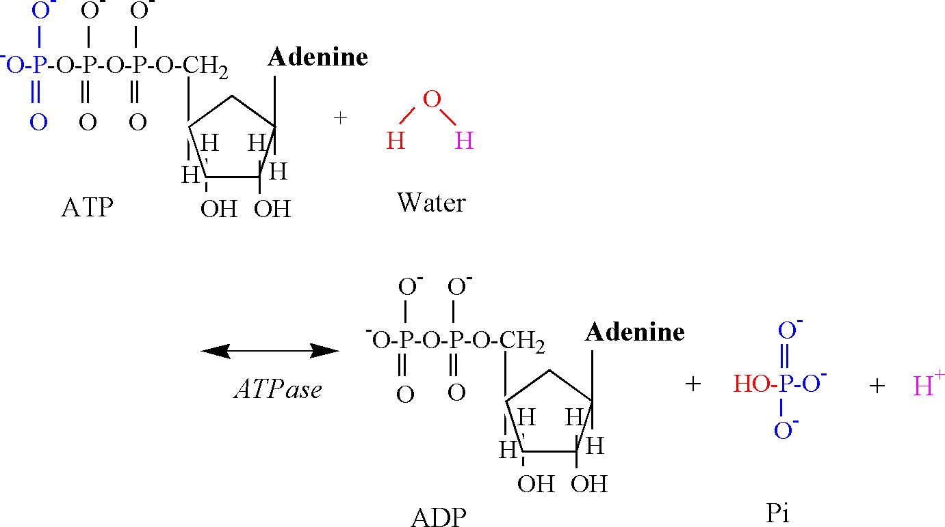
When the rate of cytosolic ATP hydrolysis exceeds the rate at which the mitochondria can remove and/or utilize the products of the reaction, the products can accumulate. The ADP does not accumulate to a significant degree due to the AK and CK reactions. However, the Pi and protons are left to accumulate, with the proton gain being potentially more than Pi due to the use of Pi as a substrate in Phase 2 of glycolysis, as previously explained. Consequently, ATP hydrolysis can become a significant source of protons during moderate to intense exercise intensities, thereby contributing to the development of acidosis.
The free inorganic phosphate is not a strong acid, because all but one proton has dissociated at physiological pH, leaving HPO₄⁻². Interestingly, inorganic phosphate can function as a buffer as pH falls, because the pK' of one of the hydroxyl functional groups is 6.82 (Table 1). The pH-dependent buffering potential of Pi is revealed in 31-Phosphorous magnetic resonance spectroscopy (³¹P-MRS), via a shift in the frequency spectrum of Pi when the Pi becomes protonated. This shift is used to calculate cytosolic pH using a modified Henderson-Hasselbalch equation (Kent-Braun et al., 1993).
Phosphagen Energy System: Summary
During exercise of increasing intensity into non-steady state, the activity of the CK reaction increases. The CK reaction decreases CrP, at the same time consuming a proton. Together with the AK reaction, cellular ATP concentrations are well maintained, despite the inadequacy in the rate of ATP regeneration by mitochondrial respiration.
These cellular conditions are also associated with an increase in Pi. However, the accumulation of this molecule is not a result of the CK reaction as is generally believed within sports and exercise science, but results from a net dephosphorylation of ATP during muscle contraction. An increasing cellular Pi concentration therefore indicates that the cell is lagging behind in the regeneration of ATP from mitochondrial respiration, as Pi is not re-used by glycolysis or transported into the mitochondria as a substrate for oxidative phosphorylation.
When the cell develops an inability to supply all cellular ATP needs from mitochondrial respiration, it is a gradual process and not readily detected by assaying ATP due to the effectiveness of the CK and AK reactions, as well as an increasing rate of ATP regeneration from glycolysis. Nevertheless, ATP hydrolysis releases a proton, and when unmatched by an equal rate of mitochondrial respiration derived ATP regeneration, this proton is left to accumulate in the cytosol (Kent-Braun et al., 1993). The power of proton release from ATP hydrolysis is in direct proportion to the rate of ATP turnover. However, to a small extent the proton yield from ATP hydrolysis is reduced by the proton consumption of the CK and AMP deaminase reactions. As acidosis increases (pH<6.9), added proton buffering is provided by phosphate groups (Pi, hexose and triose phosphates).

Table 2: The two phases of glycolysis, with a tally for ATP and proton (H⁺) production.
Reaction | Enzyme | ATP | H⁺
Phase 1: 1 x 6 carbon intermediates
Glucose + ATP → Glucose 6-phosphate + ADP + H⁺ | Hexokinase | -1 | 1
Glucose 6-phosphate → Fructose 6-phosphate | Phosphoglucose isomerase
Fructose 6-phosphate + ATP → Fructose 1,6-bisphosphate + ADP + H⁺ | Phosphofructokinase | -1 | 1
Fructose 1,6-bisphosphate → dihydroxyacetone phosphate + glyceraldehyde 3-phosphate | Aldolase
Phase 2: 2 x 3 carbon intermediatesª
dihydroxyacetone phosphate ↔ glyceraldehyde 3-phosphate | Triose phosphate isomerase
glyceraldehyde 3-phosphate + Pi + NAD⁺ → 1,3 bisphosphoglycerate + NADH + H⁺ | Glyceraldehyde 3-phosphate dehydrogenase |  | 2
1,3 bisphosphoglycerate + ADP → 3-phosphoglycerate + ATP | Phosphoglycerate kinase | 2
3-phosphoglycerate → 2-phosphoglycerate | Phosphoglyceromutase
2-phosphoglycerate → Phosphoenolpyruvate + H₂O | Enolase
Phosphoenolpyruvate + ADP + H⁺ → Pyruvate + ATP | Pyruvate kinase | 2 | -2
ATP and H⁺ tally |  | 2 | 2
ªATP and H⁺ tally in Phase 2 are for the breakdown of one molecule of glucose.
Adapted from Stryer (1988).

Glycolysis
The reactions of glycolysis are listed in Table 2. Two reactions of Phase 1 and one reaction of Phase 2 release protons, whereas one reaction of Phase 2 consumes protons. Consequently, when starting from glucose or glycogen, glycolysis yields a net of two protons per glucose flux to 2 pyruvate. Increasing glycolytic flux increases net proton release and the need for proton buffering.
The hexokinase reaction is the first proton releasing reaction of glycolysis, and is illustrated in Figure 5. The hydroxyl group of the sixth carbon is split during this reaction, releasing a proton. The oxygen and electron remain to accept the phosphate group transferred from ATP.

Figure 5: A structural illustration of the hexokinase reaction. Note the color-coded atoms and bonds pertinent to the mechanism of the reaction.
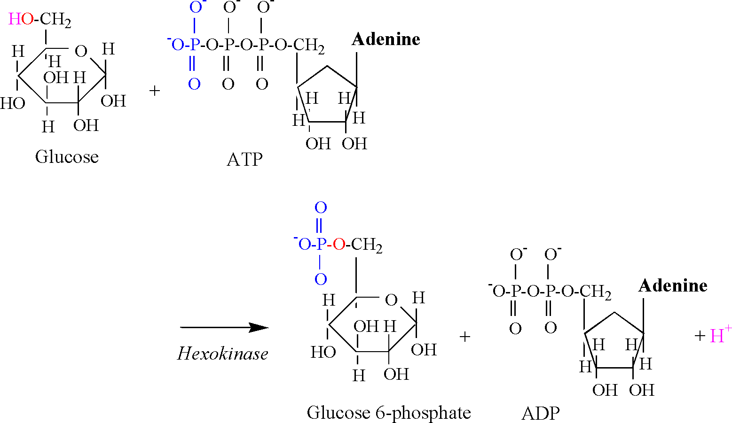
The second proton releasing reaction of glycolysis is catalyzed by phosphofructokinase (PFK), and is illustrated in Figure 6. As for the hexokinase reaction, the hydroxyl group of the first carbon is split, releasing a proton, followed by the acceptance of the phosphate group transferred from ATP.
Glyceraldehyde 3-phosphate dehydrogenase (G₃PDH) catalyzes the third proton releasing reaction of glycolysis (Figure 7). The aldehyde group of the third carbon is oxidized by NAD⁺, resulting in the removal of two electrons and a proton. A proton is also removed from Pi, allowing the Pi to bind to the third carbon, forming 1,3 bisphosphoglycerate.
The G₃PDH reaction is functionally and bioenergetically coupled to the phosphoglyerate kinase (PGK) reaction (Figure 8). Note that the PGK reaction produces the first acid intermediate of glycolysis; 3-phosphoglycerate. In an early edition of his textbook, Lehninger (1993) explained that this reaction produced a proton via ionization of 3-phosphoglycerate at physiological pH. However, this presentation should not be applied to in-vivo conditions, as Lehninger was illustrating the reaction mechanism of hydrolysis, which in vitro occurs without the coupling of the reaction to ADP phosphorylation.

Figure 6: A structural illustration of the phosphofructokinase reaction. Note the color-coded atoms and bonds pertinent to the mechanism of the reaction.
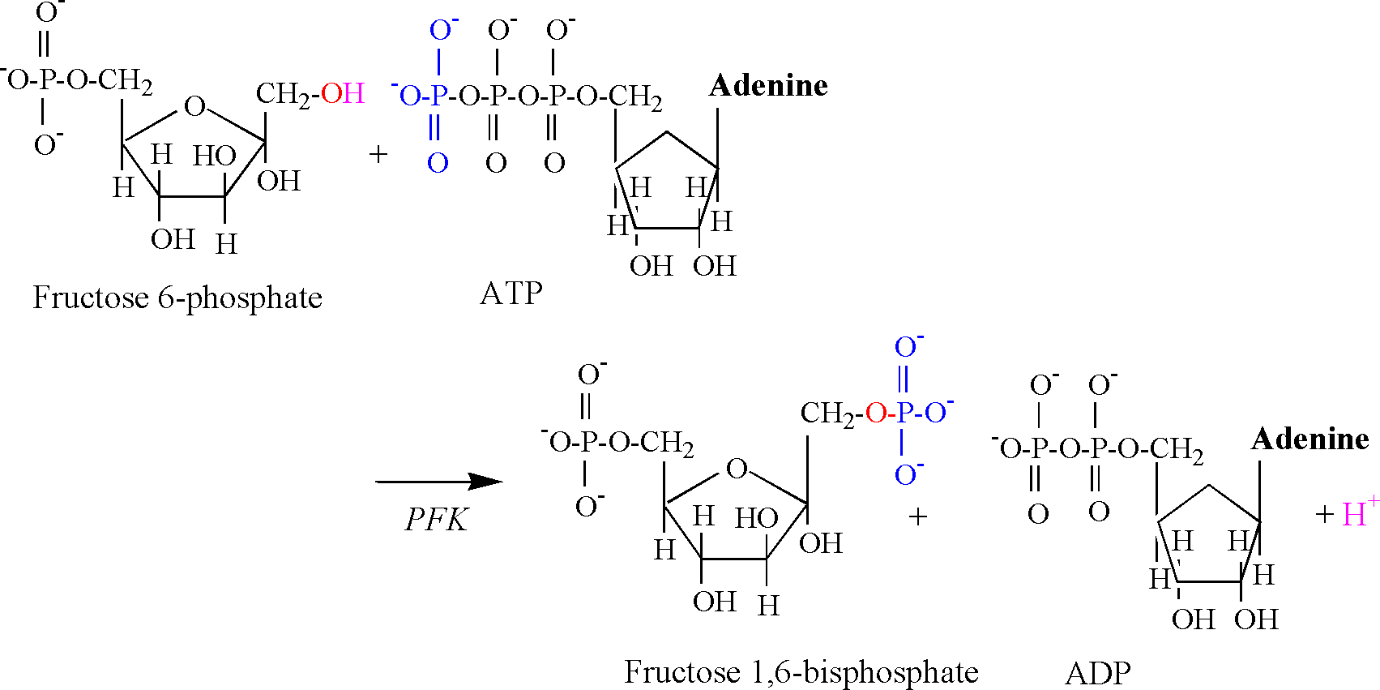

Figure 7: A structural illustration of the glyceraldehyde-3-phosphate dehydrogenase reaction. Note the color-coded atoms and bonds pertinent to the mechanism of the reaction.
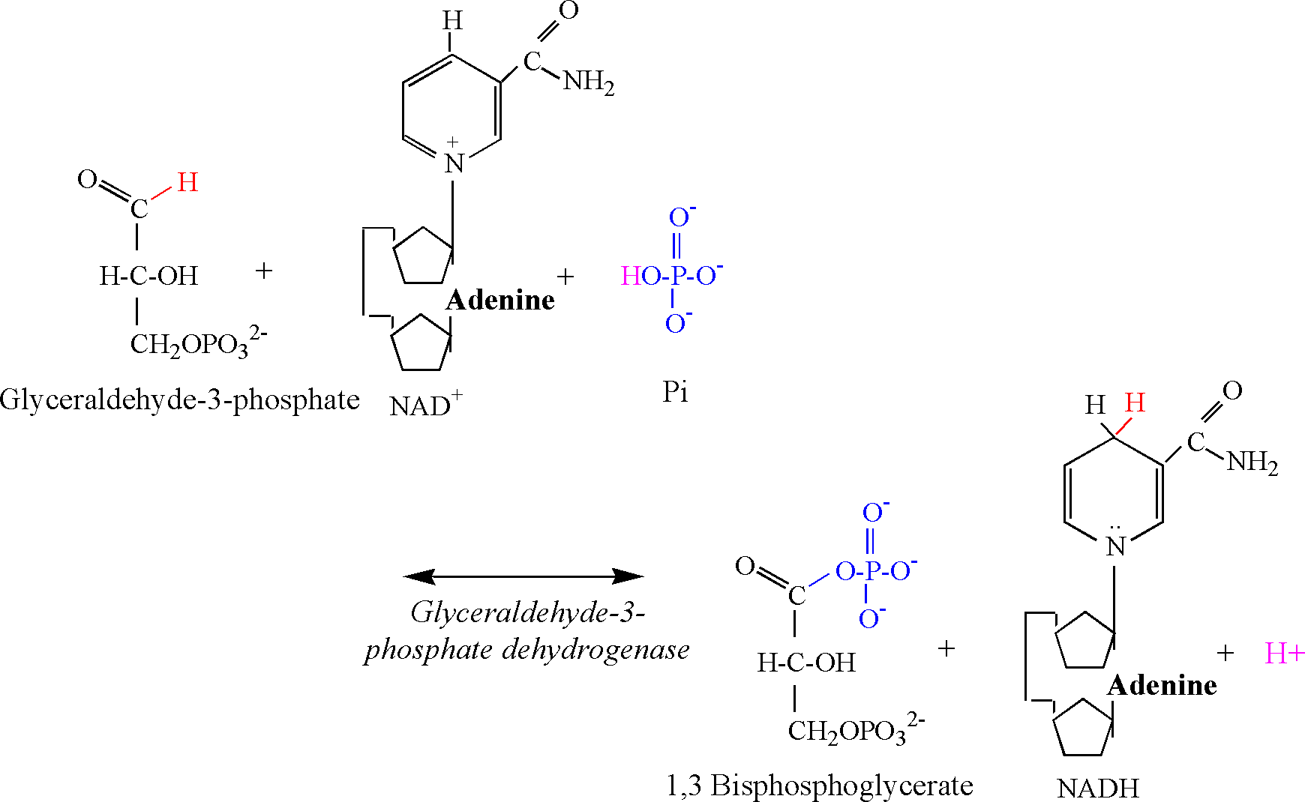
The PGK reaction involves a simple phosphate transfer from the first carbon of 1,3 bisphosphoglycerate to ADP, forming ATP. An oxygen and electron remain on the carboxylic acid functional group of 1,3 bisphosphoglycerate. There is no proton involved in this transfer, and 3-phosphoglycerate is formed devoid of a proton. This same carboxyl group remains unprotonated for the remaining intermediates of glycolysis. This important biochemical fact means that there never was a proton released by the carboxyl group of 3-phosphoglycerate or any of the following glycolytic intermediates. Thus there is no proton associated with the carboxyl group when lactate is produced. The only conclusion to be made from this biochemical fact is that it is impossible for lactate production, or that of any “downstream” carboxylic intermediate from 3-phosphglycerate, to cause the release of a proton and a subsequent acidosis. This fact alone obliterates the notion of a “lactic acidosis”.

Figure 8: A structural illustration of the phosphoglycerate kinase reaction. Note the color-coded atoms and bonds pertinent to the mechanism of the reaction.
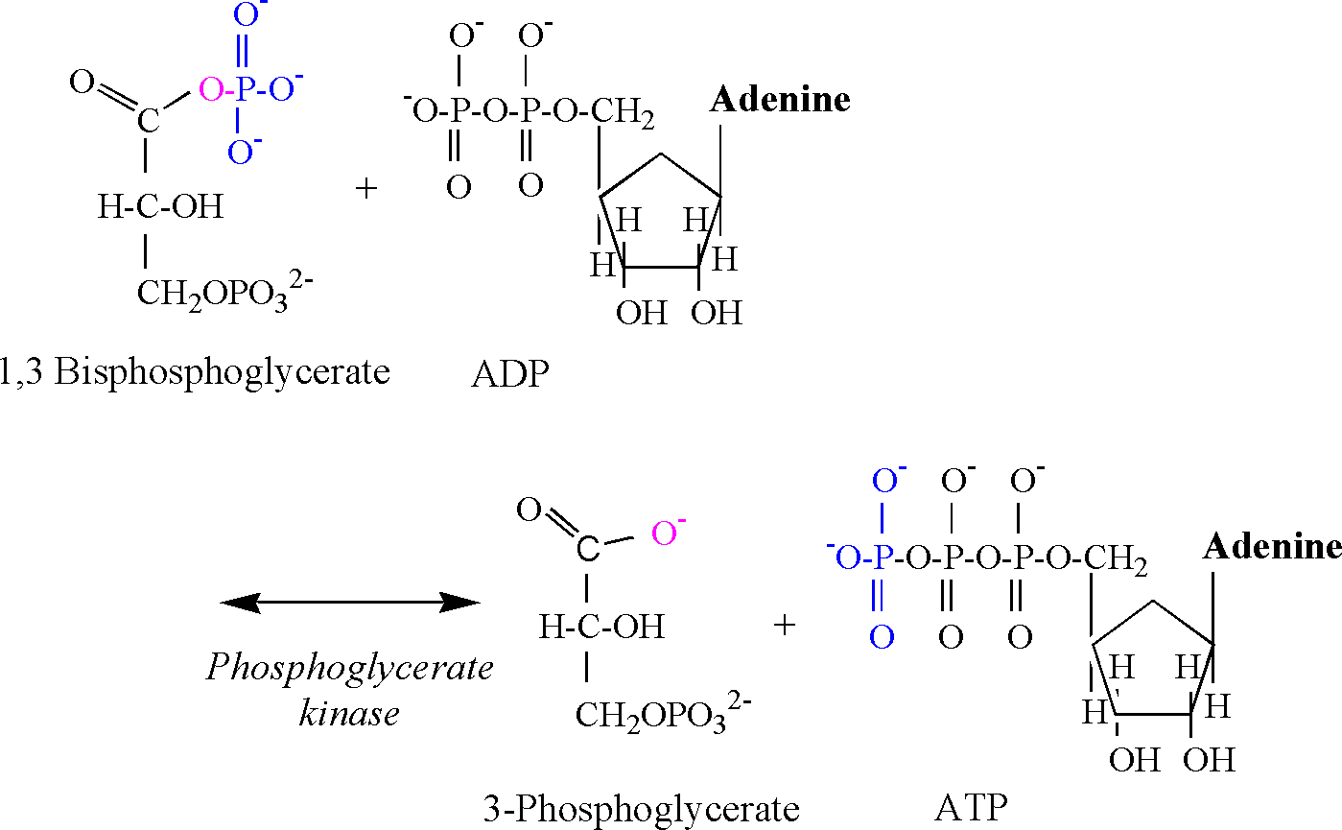
The pyruvate kinase reaction consumes a proton, and is illustrated in Figure 9. The phosphate group attached to the second carbon of phosphoenolpyruvate is transferred to ADP, forming ATP. The preferred chemical state of pyruvate is an enol form (second carbon double bond to oxygen), and a proton is required from solution to bind to the third carbon to complete the chemical structure.

Figure 9: A structural illustration of the pyruvate kinase reaction. Note the color-coded atoms and bonds pertinent to the mechanism of the reaction.
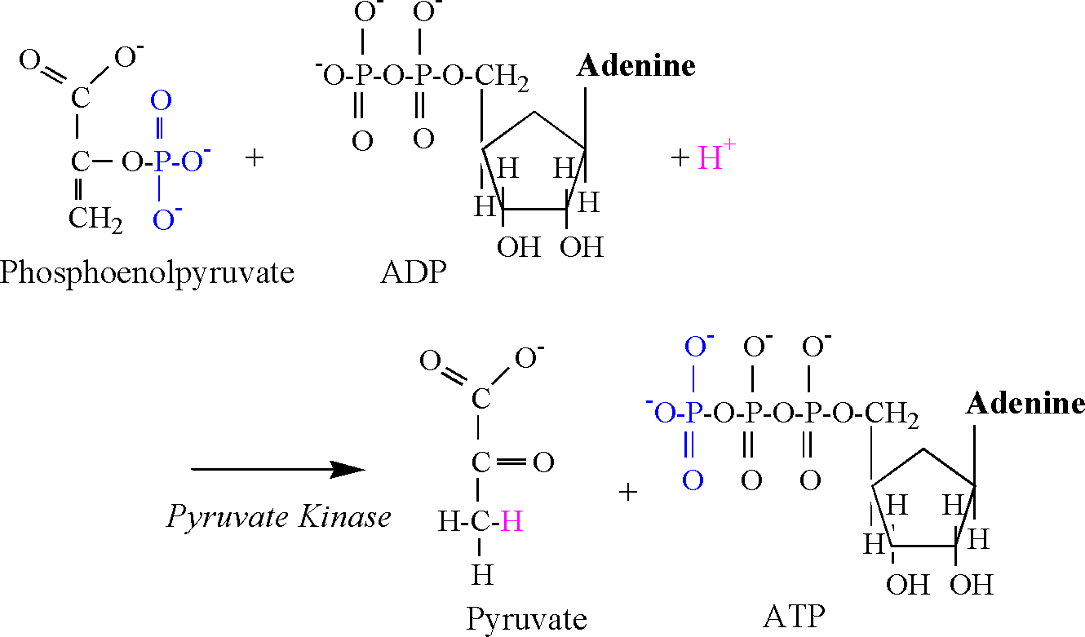

The Lactate Dehydrogenase Reaction
Once pyruvate is produced, it can be transported into the mitochondria and oxidized via the pyruvate dehydrogenase complex reaction, or reduced to lactate in the cytosol via LDH. The chemical equation of the LDH reaction follows:
Pyruvate + NADH + H⁺ ↔ lactate + NAD⁺
The reduction of pyruvate involves the addition of 2 electrons and 1 proton from NADH, and 1 proton from the cytosol (Figure 10). The second carbon of pyruvate is reduced by the addition an electron and proton from NADH, forming the covalent bond to hydrogen. Another electron from NADH and a proton from solution are used to form the hydroxyl group. As previously explained, there is no proton associated with the carboxyl group, and therefore no proton release and ionization. Thus, the LDH reaction consumes a proton, thereby functioning as a sink for protons produced in catabolism and ATP hydrolysis.

Figure 10: A structural illustration of the lactate dehydrogenase reaction. Note the color-coded atoms and bonds pertinent to the mechanism of the reaction.
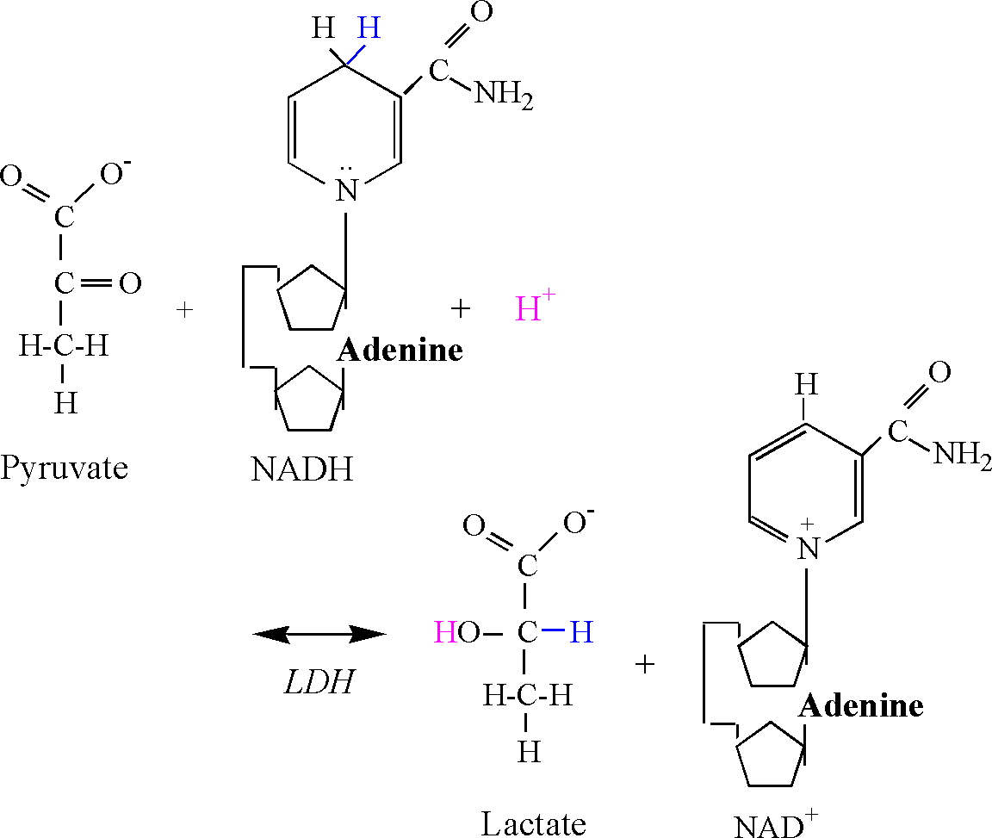

The Balance of Proton Production and Consumption in Muscle Contraction
Based on the metabolic biochemistry presented, an estimation of the balance of proton production and consumption (including buffering) can be made. However, such estimates only represent the proton exchange resulting from the reactions of the phosphagen and glycolytic systems, as modified by carbohydrate oxidation in mitochondrial respiration. Added proton exchange occurs during amino acid oxidation and associated amination and deamination reactions. In addition, blood and tissue acid-base balance is further complicated during ketosis. Nevertheless, during short-term intense exercise to fatigue, it is fair to conclude that the phosphagen and glycolytic systems represent the bulk of proton exchange.
When accounting for proton production in the cytosol during muscle contraction, the sources are glycolysis and ATP hydrolysis. For proton consumption, the contributors are the CK reaction, AMP deaminase reaction, mitochondrial respiration, Pi and additional intracellular buffers, and proton efflux from the cell (Table 3). It should be noted that as pH decreases, Pi (free and hexose- and triose phosphates) becomes a stronger buffer of protons due to the increased proportion of the molecules that consume a proton from solution (forming H₂PO₃⁻). For simplicity, I have not based calculations on fractional contributions to proton exchange. This decision is based on past research and reviews on this topic which reveals that magnesium is bound to all adenylates, thereby lowering pK values to non-physiologically acidic levels (Karlsson, 1971). Furthermore, the proton buffering of Pi is minimal, and fractional representation of this component causes minimal change to the overall tally of proton exchange.

Table 3: The predominant reactions contributing to proton release and consumption in contracting skeletal muscle.
H⁺ Release | Power or Capacityª
Glycolysis | 0.6 mmol H⁺/mmol pyruvate^{b} or 1.5 mmol H⁺/kg/s^{c}  or 18 mmol H⁺/kg for 64 contractions (102 s)^{c}  0.6 x 215 = 129 mmol H⁺/kg/3 min^{d}
ATP hydrolysis | 1 mmol H⁺/mmol or 2.0 mmol H⁺/kg/s (30 s)^{d}  or 1.45 mmol H⁺/kg/s (180 s)^{d}  or 215 mmol/kg/3 min^{d}
H⁺ Consumption | Power or Capacityª
CK reaction | 1 mmol H⁺/mmol or 20 mmol H⁺/kg
LDH reaction | 1 mmol H⁺/mmol; in muscle = 30 mmol H⁺/kg;  released into blood = 10 mmol/L of blood  or 2.5 mmol/kg of active muscle
Ammonia formation | Fitness/training status dependent  3 mmol H⁺/kg/3 min^{d}
Mitochondrial respiration | Fitness/training status dependent  0.8 mmol H⁺/kg/s^{e} or 144 mmol H⁺/kg/3 min^{e}
Extracellular transport | ? pH and lactate dependent
Cell buffers^{f} | 35 mmol H⁺/kg
ªAll concentrations expressed wet weight; concentrations and capacities are for maximal values.
^{b}Assumes 80% contribution from glycogenolysis and 20% from blood glucose.
^{c}Based on research by Spriet et al. (1987, 1987).
^{d}Based on adjusting blood lactate by the blood volume (5 L), and correcting for 20 kg of active muscle mass.
^{e}Based on research by Medbo et al. (1993).
^{f}Comprises Pi, amino acids, proteins, hexose and triose phosphates, bicarbonate.

The data of Table 3 refer to intense exercise to fatigue, and are derived from the research of Spriet et al. (1987, 1987) and Medbo et al. (1993). I have used the data of Medbo et al. based on 3 min of cycle ergometry at 120% VO₂max to calculate a balance of proton release and consumption. As the glycolytic contribution to ATP turnover was not calculated by Medbo, I estimated it based on a 60% glycolytic contribution to total ATP turnover as recommended by Spriet (1990).
When the sum of all proton releasing components and proton consuming components are tallied, ~145 mmol H⁺/kg/3 min remains for handling by buffers and extracellular transport from the cell. This seems appropriate, as research has produced values for muscle buffering between 40 to 80 mmol H⁺/L/pH. As this is a capacity that adapts with training, using a high value of 80 mmol H⁺/L/pH is reasonable, which approximates to 59 mmol H⁺/kg/pH. It is difficult to convert this to a capacity, but with a drop in muscle pH from 7 to 6.4, this amounts to 35.4 mmol H⁺/kg. Consequently, proton efflux from muscle must approximate 110 mmol H⁺/kg/3 min, or 37 mmol H⁺/kg/min; a value that is distributed among passive proton removal, bicarbonate buffering, and the proton transporters (Na⁺, HCO₃⁻, lactate). Unfortunately, research of the proton efflux from human muscle of a heterogenous fiber type is not extensive, and it is difficult, if not impossible, to gauge the validity of the 37 mmol H⁺/kg/min estimate of proton efflux (Brooks, 2000; Juel, 1996, 1998).
As the free protons remaining in solution within a cell do not amount to a large concentration (e.g., a pH decrease from 7.0 to 6.4 results in a proton accumulation of 0.3 μmol/L, or approximately 0.22 μmol/kg), the value of 30 to 40 mmol H⁺/kg/min for proton efflux is high. Nevertheless, the aforementioned calculations of proton balance are more realistic than if acidosis was dependent on lactate production.
Assuming that 25% of total muscle lactate is removed during 3 min of intense exercise to fatigue, then approximately 40 mmol/kg lactate/3 min is produced. When accounting for the added proton consuming reactions of metabolism (i.e., ignoring that the LDH consumes a proton!), net proton release from lactate during 3 min of exhausting exercise would only amount to 17 mmol/kg (40–20–3 = 17 mmol/kg). Based on the muscle buffer capacity (35.4 mmol H⁺/kg), and the above estimate of proton efflux from muscle (110 mmol H⁺/kg/3 min), this value for lactate-related proton release is only 15% of the total protons accounted for by buffering and efflux. Clearly, the concept of a “lactic acidosis” is not supported by biochemistry, or from data of muscle lactate production, and proton buffering and efflux during intense exercise to fatigue.
Summary of Cytosolic Proton Exchange

The balance of the proton-releasing and proton-consuming reactions of catabolism in skeletal muscle needs to be presented in a manner that expresses the simultaneous activity of all pertinent reactions. I have tried to do this for the cytosolic reactions in Figure 11, and this illustrative summary of the prior content of this manuscript needs to be applied to the capacities and power of proton release and consumption summarized in Table 3.
During exercise of low intensity, glycolytic flux is low, the predominant substrate for energy catabolism is fatty acids, and consequently, a muscle’s ATP needs are met largely by mitochondrial respiration. With an increase in exercise intensity, blood flow and glucose uptake into skeletal muscle increases. In addition, free calcium and Pi increase slightly, thereby increasing the activity of phosphorylase. The additional glucose uptake and increasing rate of glycogenolysis increase glycolytic flux, and in so doing, decrease the relative contribution of fatty acid oxidation to total ATP regeneration. With an increasing glycoytic flux, yet still a steady state intensity, there is also an increase in proton release. However, the protons are consumed by lactate production and transport into the mitochondria for use in oxidative phosphorylation.
As the exercise intensity increases to now exceed the threshold point for the handling of the cytosolic ATP demand by mitochondrial respiration, there are transient increases in ADP, causing an increased rate of the CK reaction. In addition, Pi begins to accumulate, providing added substrate for glycogenolysis and glycolysis, further increasing substrate flux through glycolysis. These events lead to rapid increases in proton release due to an increasing dependence on glycolysis for sustaining the cellular ATP concentration. Consequently, the main cause of an increasing proton release is the greater rate of glycolytic flux, plus the now increasing dependence on glycolytic ATP turnover. The increasing substrate flux through glycolysis, accompanied by decreases in the cytosolic redox (NAD⁺/NADH) results in an increased rate of lactate production (Sahlin et al., 1987).

Figure 11: A summary of the biochemical events that contribute to metabolic acidosis. Protons, colored red, are produced from glycolysis and ATP hydrolysis. When the rate of ATP turnover from mitochondrial respiration falls behind the rate of ATP demand in the cytosol, ADP, Pi, and AMP can all accumulate. Under these conditions, and despite the protons consumed by the CK and AMP deaminase reactions, the protons released from ATP hydrolysis and from glycolysis (the excess not consumed by the production of lactate) contribute to the development of cellular acidosis.
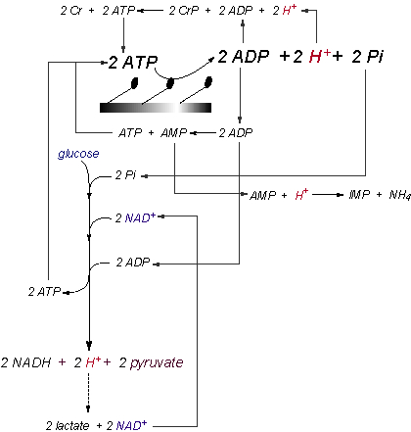

Lactate production is beneficial for regenerating NAD⁺ as well as consuming a proton. Nevertheless, the capacity of the LDH reaction to maintain cytosolic redox and retard a worsening acidosis depends on the maximal rate of proton efflux from the cell. Fortunately, the lactate transporter also co-transports a proton. Additional proton transporters also exist (Na⁺ and HCO₃⁻). Thus, lactate production has a third advantage: assisting proton efflux from muscle. Despite these benefits, the lactate-proton transport is rate limiting, and as lactate accumulates in the cytosol, the bioenergetics of the LDH reaction become less favorable, and the rate of lactate production decreases. During sustained intense exercise, the rate of pyruvate and lactate production is also decreased due to a reduction in the rates of glycogenolysis and glycolysis, which occur as early as 30 s into a 3-min bout of intense exercise. The accummulation of pyruvate in the cytosol of the cell, and the accumulation of acetyl units in the mitochondria reflect a glycolytic activity that does not end in lactate production or the complete oxidation of glucose carbons. Thus, added protons accumulate and acidosis is worsened.
Application of Biochemistry of Acidosis to Exercise Physiology

Clearly, there is no biochemical evidence for lactate production releasing a proton and causing acidosis. Nor is there any evidence that lactate production increases in equal amounts to the number of protons released within and from skeletal muscle. Consequently, the cause of acidosis should be taught to be a result of exercise intensities that are now non-steady state. Such conditions result in further increases in the rate of glycolysis, and increased dependence on cytosolic ATP turnover due to a mismatch between the rate of ATP demand (muscle contraction) and supply from mitochondrial respiration.
These cellular conditions have large implications to how we understand exercise physiology. For example, lactate production retards, not worsens acidosis. A greater capacity to produce and remove lactate from the cell would delay the onset of acidosis. This means that during intense exercise, high lactate production is beneficial to the athlete, especially when accompanied by a high capacity for lactate and proton transport from the cell, capacities that are known to increase with both endurance and power/sprint training (Juel, 1998).
The temporal alignment between the cellular conditions leading to acidosis and an increased production of lactate are not changed by this biochemical explanation of acidosis. Lactate is obviously a good indirect marker of an alteration in cellular metabolism causing acidosis and a non-steady state cellular metabolic milieu. However, lactate production does not cause the acidosis.
Another application of the biochemistry of metabolic acidosis relates to the recruitment of fast twitch motor units. As exercise intensity increases, Type IIa and IIb motor units become progressively recruited. As the muscle fibers of these motor units have a lower mitochondrial density than Type I fibers, they are more reliant on glycolysis and cytosolic ATP turnover. As these two traits combine to increase the net rate of proton release from catabolism, a considerable proton production ensues during the exercise intensities associated with increased Type II motor unit recruitment. As such, type II fibers contribute to acidosis, not because they produce more lactate, but because they have less mitochondria to assist in ATP regeneration, and uptake of protons.
The biochemistry of acidosis also has clinical implications. Obviously, attempting to prevent acidosis by inhibiting lactate production will worsen, not prevent, acidosis. The best means to prevent or delay acidosis is to decrease reliance on glycolysis, improve the contribution of ATP turnover from mitochondrial respiration, and increase the capacity of proton buffering and lactate-proton removal. The former strategies are typical for endurance training, and the latter strategy is applicable to strength and power training. However, clinical strategies would relate to increasing lipid oxidation by raising blood free fatty acids, or stimulating mitochondrial function.
Why is Lactic Acid Still Thought to Cause Acidosis?
Despite the biochemical realities I have presented, the fact remains that most academics and researchers within the pure and applied fields of physiology and biochemistry still think that lactate production causes acidosis.
One major explanation for this fact is that the biochemistry sections in textbooks do not present chemical equations balanced for protons and water. Thus, I had to apply my own knowledge of organic chemistry to derive the diagrams of chemical reactions presented in this article. Most PhDs and physicians simply have not been educated correctly about the biochemistry of energy metabolism in skeletal muscle. Ironically, even the main textbooks of biochemistry do not devote a chapter to explaining the biochemistry of metabolic acidosis. Specific coverage is warranted for this important topic.
Textbooks of exercise physiology are even worse in their treatment of the biochemistry of acidosis. Acidosis is attributed to the production of “lactic acid” which, when ionized at cellular pH, releases a proton into solution. This explanation is made without any support from research or biochemistry. I have clearly shown the shortcomings of this explanation. Until textbooks detail the realities of the biochemistry of acidosis, the myth of lactic acidosis will continue.
Editor’s Comment
Rob’s Figure 11 is an elegant summary of the flow of compounds involved in energy consumption and anaerobic energy production during exercise. If we follow the fate of a molecule of glucose down this pathway, we end up with two lactates. Along the way, we use up two ADP and generate two ATP, and that’s all. There is no nett production of H⁺. But ATP and ADP don’t change, because muscle contraction breaks the two ATP back down to two ADP, two Pi, and, of course, two H⁺. So we end up with two lactates and two H⁺ for each molecule of glucose. We’ve turned glucose into lactic acid, but the lactate and the acid come from different places: the H⁺ from breakdown of ATP, and the lactate from breakdown of glucose. That appears to be Rob’s view, and it seems perfectly reasonable. But it's also perfectly reasonable to argue that the H⁺ comes from glucose, one way or another. The H⁺ produced in the hydrolysis of ATP comes from water, sure, but matter is conserved. Somewhere somehow in the breakdown of glucose an H⁺ is transferred to water. Ultimately, a molecule of glucose ends up as two molecules of lactate and two H⁺. I have no real objection to “lactic acidosis”.
Author’s Response
Will first contacted me about this topic after he read one of my abstracts from the 2001 annual meeting of the American College of Sports Medicine. This article arose from our interaction.
In my view, and in the view of many exercise physiologists and biochemists, “lactic acid” does not directly cause exercise-induced metabolic acidosis. Will and I have been grappling with the reasoning behind this view, and whether it has any real meaning to how we, as exercise and sports science professionals, interpret exercise-induced lactate production and acidosis. Will’s comment is consistent with the biochemical evidence.
Certainly, when looking at metabolism from a general perspective, intense exercise induces acidosis that coincides with an accumulation of lactate. My problem with the concept of a “lactic acidosis” is that it is yet another example of an exercise and sports science oversimplification of biochemical fact for the sake of simplicity and expedience. It bothers me that Will still wants to generalize facts to an association between acidosis and lactate. In my experience, the generalizations within exercise and sports science are negative reflections on us, and it is no wonder that our field is viewed poorly by many (not all) academics and researchers in the pure sciences. Exercise-induced metabolic acidosis is far more complex than to lay blame on one reaction and product, and we should accept the challenge of being true scientists to explain the reality of cellular acidosis.
The point is not whether it really makes a major difference, or whether the net result is or is not lactate accompanied by protons. Let’s teach the facts and then let us see where the truth takes us: in education, in research, and in clinical applications.
Finally, it is important to realize that although Will’s assessment of the lactate and proton balance is reasonable (2 lactate + 2 protons), the fact remains that because the protons do not come from the production of lactate, there is potential for an uncoupling of the ratio of protons to lactate. For example, lactate production will underestimate the net proton release when the pyruvate that does not enter the mitochondria is incompletely converted to lactate (increase in cellular pyruvate). Similarly, when pyruvate is transported into the mitochondria, converted to acetyl CoA, and these acetyl groups accumulate in the mitochondria due to an insufficiency of mitochondrial respiration, added protons also accumulate in the cytosol due to the absence of lactate production from these carbons and the accompanied proton consumption. Extra proton accumulation also occurs in the cytosol from the hydrolysis of ATP gained from the adenylate kinase reaction. For all these reasons, proton release is greater than lactate production.
References
Brooks GA (2000). Intra- and extra-cellular lactate shuttles. Medicine and Science in Sports and Exercise 32, 790-799
Busa WB, Nuccitelli R (1984). Metabolic regulation via intracellular pH. American Journal of Physiology 246, R409-R438
Dennis SC, Gevers W, Opie LH (1991). Protons in ischemia: Where do they come from; where do they go to? Journal of Molecular and Cell Cardiology 23, 1077-1086
Gevers W (1977). Generation of protons by metabolic processes in heart cells. Journal of Molecular and Cell Cardiology 9, 867-874
Gevers W (1979). Generation of protons by metabolic processes other than glycolysis in muscle cells: a critical view [letter to the editor]. Journal of Molecular and Cell Cardiology 11, 328
Hagberg H (1985). Intracellular pH during ischemia in skeletal muscle: relationship to membrane potential, extracellular pH, tissue lactic acid and ATP. Pflugers Archives 404, 342-347
Hochachka PW, Mommsen TP (1983). Protons and anaerobiosis. Science 219, 1391-1397
Juel C (1996). Lactate/proton co-transport in skeletal muscle: regulation and importance for pH homeostasis. Acta Physiologica Scandinavica 156, 369-374
Juel C (1998). Muscle pH regulation: role of training. Acta Physiologica Scandinavica. 162, 359-66
Karlsson J (1971). Lactate and phosphagen concentrations in working muscle of man. Acta Physiologica Scandinavica Supplementum 358, 1-72
Katz A, Sahlin K (1988). Regulation of lactic acid production during exercise. Journal of Applied Physiology 65, 509-18
Kent-Braun JA, Miller RG, Weiner MW (1993). Phases of metabolism during progressive exercise to fatigue in human skeletal muscle. Journal of Applied Physiology 75, 573-80
Lehninger AB, Nelson DL, Cox MM (1993). Principles of biochemistry (second edition). New York, NY: Worth Publishers
Lindinger MI, Heigenhauser GJ (1991). The roles of ion fluxes in skeletal muscle fatigue. Canadian Journal of Physiology and Pharmacology 69, 246-253
Medbo JI, Tabata I (1993). Anaerobic energy release in working muscle during 30 s to 3 min of exhausting bicycling. Journal of Applied Physiology 75, 1654-1660
Nelson DL, Cox MM (2000). Lehninger principles of biochemistry (third edition). New York, NY: Worth Publishers
Noakes TD (1997). Challenging beliefs: ex Africa semper aliquid novi. Medicine and Science in Sports and Exercise 29, 571-590
Sahlin K (1978). Intracellular pH and energy metabolism in skeletal muscle of man. Acta Physiologica Scandinavica 455, S7-50
Sahlin K, Katz A, Henriksson J (1987). Redox state and lactate accumulation in human skeletal muscle during dynamic exercise. Biochemical Journal 245, 551-556
Spriet LL, Sunderland K, Bergstrom M, Hultman E (1987). Anaerobic energy release in skeletal muscle during electrical stimulation in men. Journal of Applied Physiology 62, 611-615.
Spriet LL, Sunderland K, Bergstrom M, Hultman E (1987). Skeletal muscle glycogenolysis, glycolysis, and pH during electrical stimulation in men. Journal of Applied Physiology 62, 616-621
Spriet LL (1990). Anaerobic meatabolism in human skeletal muscle during short-term, intense activity. Canadian Journal of Physiology and Pharmacology 70, 157-165
Stewart PA (1983). Modern quantitative acid-base chemistry. Canadian Journal of Physiology and Pharmacology 61, 1444-1461
Stringer W, Wasserman K, Casaburi R, Porszasz J, Maehara K, French W (1994). Lactic acidosis as a facilitator of oxyhemoglobin dissociation during exercise. Journal of Applied Physiology 76, 1462-1467
Stryer L (1988). Biochemistry (third edition). New York, NY: W.H. Freeman
Vaghy PL (1979). Role of mitochondrial oxidative phosphorylation in the maintenance of intracellular pH. Journal of Molecular and Cell Cardiology 11, 933-940
Wilkie DR (1979). Generation of protons by metabolic processes other than glycolysis in muscle cells: a critical view. Journal of Molecular and Cell Cardiology 11, 325-330
Zilva JF (1978). The origin of the acidosis in hyperlactataemia. Annals of Clinical Biochemistry 15, 40-43
Edited and webmastered by Will Hopkins.
Published Sept 2001.
editor@sportsci.org
©2001

